**Cyber Security Basic Tasks**

**Task 1: Set Up Basic Firewall Rules**

* **Ubuntu Firewall (UFW) Configuration (Enable UFW)**

To enable Firewall in Ubuntu run the command: sudo ufw enable

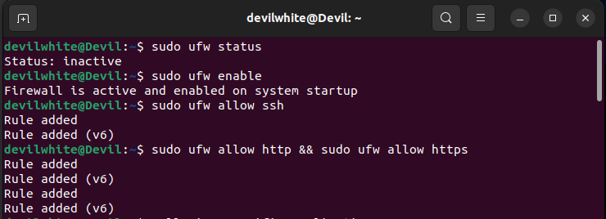

* Allow Specific Applications or Ports**:**

To Allow port 22 which is used for ssh: sudo ufw allow ssh



To allow Application: sudo ufw allow app_name



* Block Specific Ports or Applications: sudo ufw deny port_number && sudo ufw deny app_name

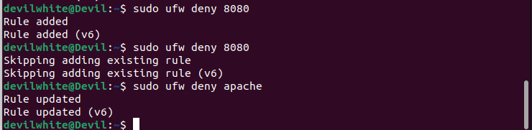

* Advanced Rules**:**

Allow traffic from a specific IP: sudo ufw allow from IP_Address



Deny all incoming connections except those explicitly allowed: suo ufw default deny incoming && sudo ufw default allow outdoing

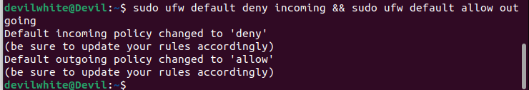

* Check and Apply Changes: sudo ufw verbose

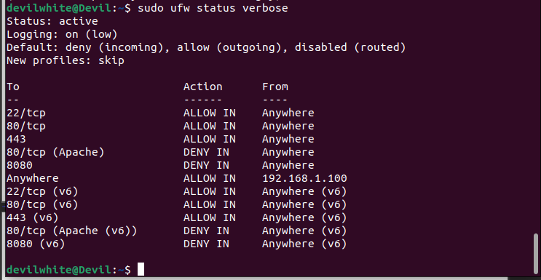

* Disable UFW (if necessary): sudo ufw disable



**Task 2: Use a Password Manager**

* Install a Password Manager**:**

Bitwarden Installation:

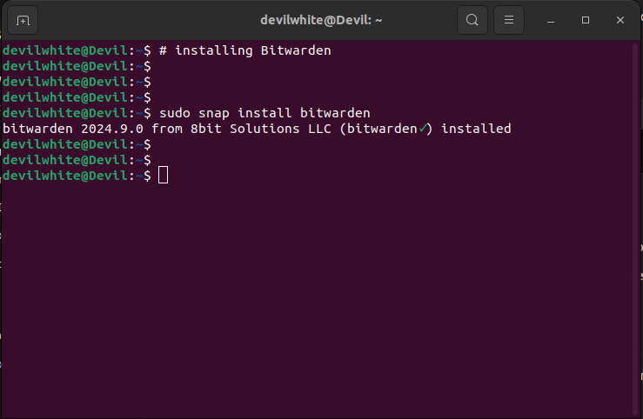

* Setting Up Bitwarden**:**

**Creating an account**

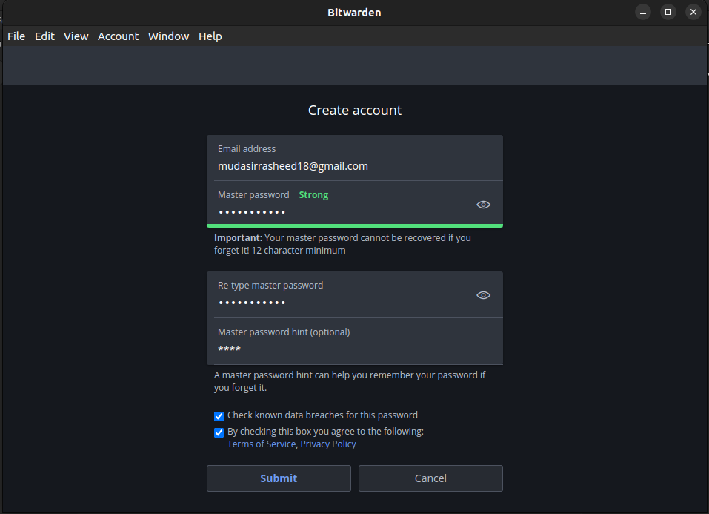

**Adding Password**

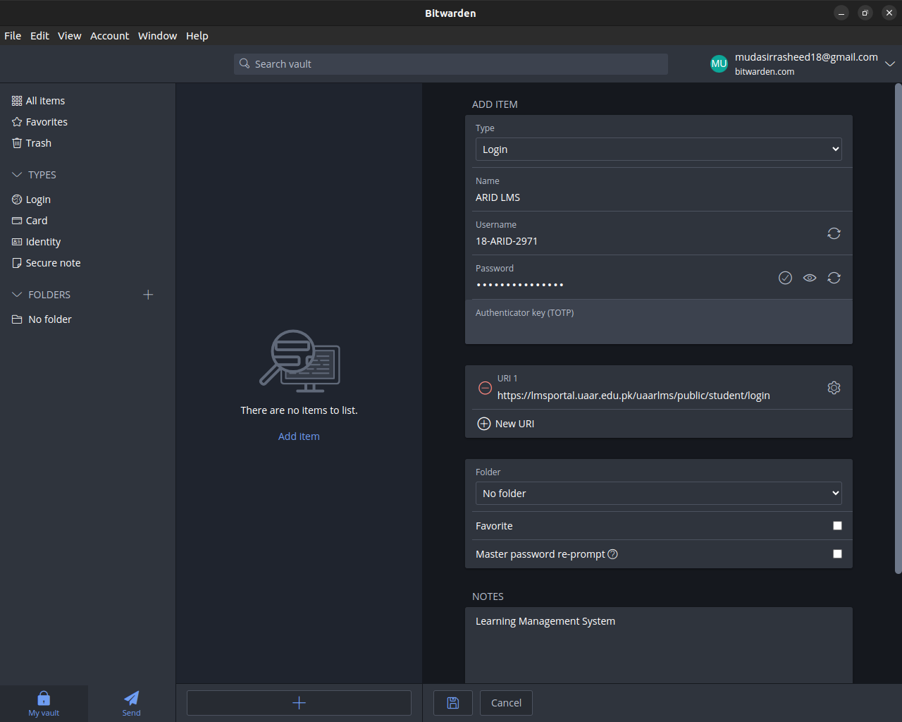

**Generating Strong Password Using Bitwarden:**

